MISSION PLANNING SYSTEM (MPS)
Pre-mission planning is the most important part of any successful combat mission. In addition to the mission objective itself, locations of enemy air defenses, terrain, and even the weather should be considered when planning each phase of the mission, based on how the unit intends to execute their assigned mission(s).


Mission planners and pilots utilize specialized software installed on the unit’s Mission Planning Systems to plan all aspects of the mission such as routes, hazards, phase lines, engagement areas, fire support control measures, locations of enemy air defenses, radio settings, datalink configurations, and chaff/flare programs. This data is then transferred onto a removeable Data Transfer Cartridge (DTC) for uploading to the AH-64D’s onboard memory via the cockpit DTU receptacle. (See the DMS Data Transfer Unit sub-page for more information.)
Two separate “Missions” may be stored on the DTC, each with a unique 149-point database, 10 routes, 12 engagement areas, 15 lines, and 16 zones; the entirety of which may be transmitted directly to other AH-64Ds across the datalink to facilitate mission file updates just prior to takeoff or during the mission itself.

MISSION 1/MISSION 2
- WPTHZ Waypoints/Hazards
- CTRLM Control Measures
- TGT/THRT Targets/Threats
- LINES Battlefield Lines
- AREAS Engagement Areas
- ZONES Priority Fire Zones and No Fire Zones
- ADF Radio beacon presets
- ROUTES Route sequences
COMMUNICATIONS
- RADIOS Radio settings
- PRESETS COM Presets and MPS Text messages
WEAPONS/SIGHTS
- WEAPON SETTINGS
Pilot/CPG weapon settings
- LASER CODES LRFD/LST
settings and laser codes
MISCELLANEOUS
- ASE Pilot/CPG autopage settings, RLWR settings, and chaff/flare programs
- RLWR threat tables
- PERF/A-ICE MAX/PLAN
data and anti-ice mode

Each of the DTC file partitions listed above may be edited using the DTC Manager, as described on the following pages, from within the Mission Editor, at the beginning of the mission, or during gameplay while on the ground.

Data Transfer Cartridge (DTC) Manager
The DTC Manager may be used to program DTC files for use in the DCS: AH-64D. DTC files may be created for use in a specific DCS Mission by the mission maker or they may be created by individual players for use at their discretion, in both singleplayer and multiplayer gameplay. The DTC Manager is available from within the Mission Editor prior to gameplay, or during gameplay itself while the Mission is running.
NOTE: During “multicrew” gameplay in which two players are occupying the same AH-64D during a multiplayer session, only the primary player in the Pilot seat may utilize the DTC Manager.

Mission Editor
The DTC Manager may be displayed or hidden from within the Mission Editor by pressing [Ctrl + D]. Alternatively, the DTC Manager may be accessed via the System Bar along the top of the Mission Editor, from the EDIT pull-down menu. The DTC Manager is separated into two sections, with the top portion used to manage the DTC files themselves, and the bottom portion used to program the settings within the selected DTC file.

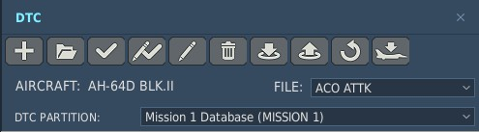
1. DTC File Management
4. DTC File Partition
3. DTC File Select
2. DTC File Type
- DTC File Management. Provides full DTC file management within the DCS Mission (.miz) file currently loaded within the Mission Editor.


New Button. Creates a new DTC file. The aircraft type and DTC file name may be selected.
•
•

•
•

•
•
•
Open Button. Opens the user’s DTC folder directory. The DTC file (.dtc) selected from within the directory will be added as a new DTC within the Mission.
Save Button. Saves the selected DTC file in its current state within the Mission.
Save As Button. Renames and saves the selected DTC file in its current state as a new DTC file within the Mission.
Rename Button. Renames the selected DTC file within the Mission.
Delete Button. Deletes the selected DTC file from within the Mission.
Import Button. Opens the user’s DTC folder directory. The data of the DTC file (.dtc) selected from within the directory will be imported into the DTC file currently displayed within the DTC Manager.
Export Button. Opens the user’s DTC folder directory. The data from the DTC file currently displayed within the DTC Manager may be saved as a new DTC file (.dtc) within the user’s DTC folder directory.
•
Load Defaults Button. Resets the data of the DTC file currently displayed within the DTC Manager to the default settings of the corresponding aircraft type.
•

•
Load To Group Button. Loads DTC files saved within the Mission to Airplane/Helicopter Groups.
- DTC File Type. Displays the aircraft type for which the selected DTC file pertains.
- DTC File Select. Displays/selects DTC files within the Mission for editing via the tabs below.
- DTC File Partition. Displays/selects data partitions within the selected DTC file. The characters annotated within the parentheses indicate the corresponding option on the DMS Data Transfer Unit sub-page that will upload the partition from the DTC to the AH-64D’s onboard memory.

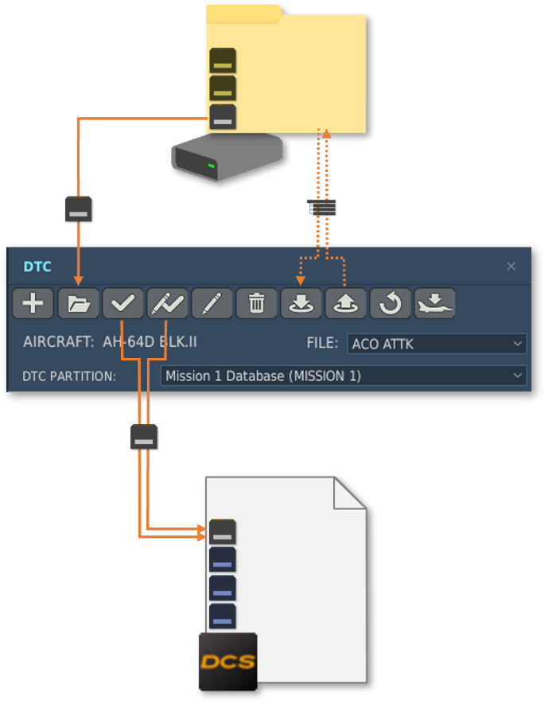
When adding a new DTC file within the DCS Mission (.miz), an entirely new DTC file with the initial settings set to the defaults may be created by pressing the New button, or an existing DTC file (.dtc) may be added from the DTC folder located within the user’s DCS settings (User>Saved Games>DCS>DTC) by pressing the Open button.
DTC Folder MyAH64.dtc GroupMsn.dtc
ACO ATTK.dtc
ACO ATTK
.dtc settings
ACO ATTK

Mission File.miz

ACO ATTK BCO ATTK MOVE2CON
ZONRECON
Once the DTC settings have been configured as desired, the DTC file may be stored within the Mission by pressing the Save button or the Save As button.
Any time a DTC file (.dtc) from the DTC folder is opened or the current DTC settings are saved, the name of the DTC file will be added to the FILE: list along the right side of the DTC Manager header, allowing it to be selected among other DTC files within the Mission.
The selected DTC file may be exported to the user’s DTC folder, or any other storage directory on the user’s computer, by pressing the Export button. The DTC settings from an existing DTC file (.dtc) within the user’s DTC folder may be imported by pressing the Import button, which will overwrite the settings within the currently selected DTC file without changing the file name or creating a new DTC file within the Mission.
NOTE: The DCS Mission (.miz) itself must be saved by pressing the Save button along the left side of the Mission Editor to save any changes that have been made to the Mission, including those made using the DTC Manager. Failure to save the Mission will result in a loss of all DTC programming that was performed since the last time the Mission file was saved, unless the DTC file was exported to the DTC folder on the user’s computer.
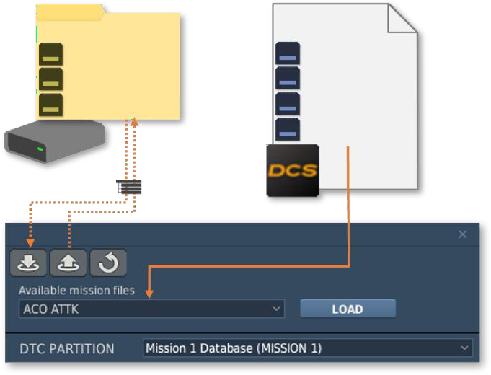


After the Mission is started in DCS, whether it be for singleplayer gameplay or a multiplayer server, the player may select a different DTC file from those that have been assigned to that particular aircraft while playing the Mission itself, using the Available mission files list. Once a DTC file has been selected, the corresponding DTC data may be loaded onto the cockpit DTC within the player’s aircraft, overwriting the existing settings, by pressing the LOAD button.
Mission File.miz
DTC Folder MyAH64.dtc GroupMsn.dtc
ACO ATTK.dtc
ACO ATTK BCO ATTK MOVE2CON
ZONRECON
.dtc settings
If a DTC file has not been assigned to the player’s aircraft within the Mission, or the player wishes to use their own pre-made DTC file, the data from an existing DTC file (.dtc) within the user’s DTC folder may be imported onto the DTC within the player’s cockpit by pressing the Import button.
(See Mission Gameplay for more information regarding how to access the DTC Manager during a DCS Mission.)

Load To Group Window
The Load To Group window allows the mission maker to rapidly load or unload DTC files within the Mission to entire Airplane/Helicopter Groups at once.

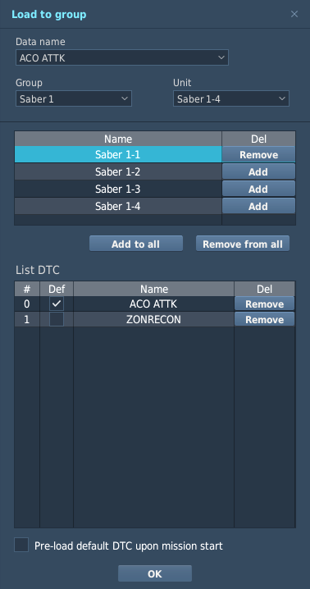
- DTC File Select. Selects DTC files within the Mission for loading.
4. Loaded DTC Files
3. Group/Unit DTC Loading
6. OK Button
5. Pre-Load DTC
1. DTC File Select
- Group/Unit Select. Selects the Group and Unit to which the selected DTC is loaded. Alternatively, a Unit may be selected by left-clicking on the Unit name within the table below.
2. Group/Unit Select

- Group/Unit DTC Loading. Loads/unloads DTC files from the Group and/or Unit.
  - Name. Displays the Unit names within the selected Group.
  - Del. The selected DTC file will be loaded into the adjacent Unit within the Name column when the Add button is pressed; or unloaded when the Remove button is pressed.
  - Add to all. Loads the selected DTC file into all Units within the selected Group.
  - Remove from all. Unloads the selected DTC file from all Units within the selected Group.
- Loaded DTC Files. Displays the DTC files that have been loaded winto the selected Unit, which is highlighted within the Group/Unit DTC Loading table above.
  - Def. When this option is checked, the adjacent DTC file within the Name column will be the default DTC loaded into the cockpit when the Mission begins in singleplayer gameplay, or when a client initially occupies the aircraft within a multiplayer server. Only one DTC file may be selected as the default.
  - Name. Displays the DTC files that have been loaded within the selected Unit.
  - Del. When the Remove button within this column is pressed, the corresponding DTC will be unloaded from the selected Unit.
- Pre-Load DTC. When this option is checked, the default DTC file will be pre-loaded when the Mission begins in singleplayer gameplay, or when a client initially occupies the aircraft within a multiplayer server.
This allows the mission maker to simulate a DTC that was uploaded by the pilot during the initial startup procedures of the aircraft if the starting position of the aircraft is in the air, on the runway, or in the parking area with the engines already running (hot start). If this option is not checked, the player will need to manually upload the DTC to the AH-64D’s onboard memory via the DMS Data Transfer Unit sub-page.
- OK Button. When pressed, the Load To Group window is closed.

DTC Tab
The DTC tab is accessed from the Airplane/Helicopter Group window and allows the mission maker to load or unload DTC files within the Mission to an individual Airplane/Helicopter Unit. This tab will only be displayed if the SKILL option is set to Player or Client.

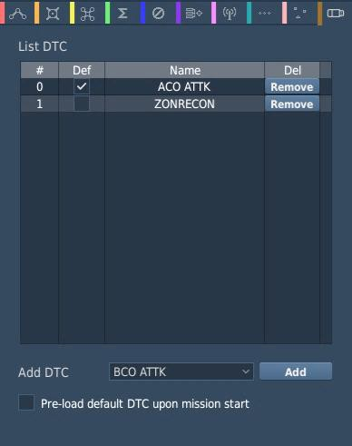
- Loaded DTC Files. Displays the DTC files that have been loaded into the aircraft.
1. Loaded DTC Files
4. Pre-Load DTC
3. Add DTC Select
2. Add Button
  - Def. When this option is checked, the adjacent DTC file within the Name column will be the default DTC loaded into the cockpit when the Mission begins in singleplayer gameplay, or when a client initially occupies the aircraft within a multiplayer server. Only one DTC file may be selected as the default.
  - Name. Displays the DTC files that have been loaded within the aircraft.
  - Del. When the Remove button within this column is pressed, the corresponding DTC will be unloaded from the aircraft.
- Add Button. Loads the selected DTC file into the aircraft.
- Add DTC Select. Selects DTC files within the Mission for loading.
- Pre-Load DTC. When this option is checked, the default DTC file will be pre-loaded when the Mission begins in singleplayer gameplay, or when a client initially occupies the aircraft within a multiplayer server.
This allows the mission maker to simulate a DTC that was uploaded by the pilot during the initial startup procedures of the aircraft if the starting position of the aircraft is in the air, on the runway, or in the parking area with the engines already running (hot start). If this option is not checked, the player will need to manually upload the DTC to the AH-64D’s onboard memory via the DMS Data Transfer Unit sub-page.

Mission Gameplay


At the start of a singleplayer mission, or when initially joining a multiplayer server, the DTC Manager may be accessed from the Briefing screen by pressing the Open DTC button. It is important to note that if the starting position of the aircraft is not at an airfield under control of the friendly coalition, this will be the only opportunity to access the DTC Manager until landing at a friendly airfield with ground support services.
If the aircraft is landed at an airfield under control of the friendly coalition and ground support services are available, the DTC Manager may be displayed or hidden by pressing [RCtrl + RShift + K]. Alternatively, the DTC interface may be accessed over the intercom via F8. Ground Crew…, F6. DTC Interface…, F1. Show.

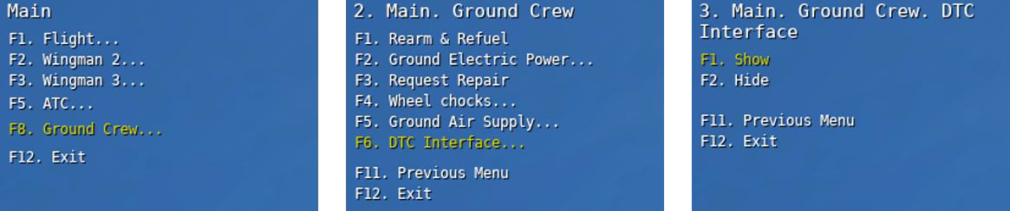
Essentially, this replicates the ground crew handing the pilot a portable mission planning computer and the pilot extracting the physical DTC from the DTU cockpit receptacle and inserting it into the computer for reprogramming. When the DTC Manager is closed, this replicates the pilot extracting the DTC from the computer, re-inserting it into the DTU cockpit receptacle, and handing the portable mission planning computer back to the ground crew.
The DTC Manager is separated into two sections, with the top portion used to manage the DTC file(s) or data partitions, and the bottom portion used to program the settings of the DTC within the player’s cockpit.

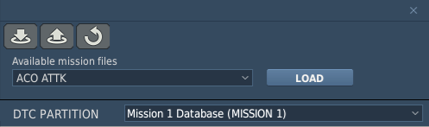
1. DTC File Management
4. DTC File Partition
3. LOAD Button
2. DTC File Select
- DTC File Management. Provides limited DTC file management for the DTC within the player’s cockpit.

Import Button. Opens the user’s DTC folder directory. The data of the DTC file (.dtc) selected from
•
within the directory will be imported onto the DTC within the player’s cockpit.
Export Button. Opens the user’s DTC folder directory. The data from the DTC within the player’s cockpit may be saved as a new DTC file (.dtc) within the user’s DTC folder directory.
•
Load Defaults Button. Resets the data of the DTC within the player’s cockpit to the default settings of the corresponding aircraft type.
•
- DTC File Select. Selects DTC files among those that have been assigned to the player’s aircraft within the Mission. If no DTC files have been assigned to the aircraft via the Load To Group window or the aircraft’s DTC tab within the Mission Editor prior to the start of the Mission, this list will be blank.
- LOAD Button. Loads the data of the DTC file selected from the available Mission files onto the cockpit DTC
within the player’s aircraft, overwriting the existing settings.
- DTC File Partition. Displays/selects data partitions within the selected DTC file. The characters annotated within the parentheses indicate the corresponding option on the DMS Data Transfer Unit sub-page that will upload the partition from the DTC to the AH-64D’s onboard memory.

Data Transfer Cartridge (DTC) Partitions
Each partition of data residing on the DTC may be selectively uploaded from the DMS Data Transfer Unit sub-page (shown below) by pressing the corresponding button. This method of uploading individual DTC partitions may be utilized if the player does not wish to overwrite all of the data or settings provided by the mission maker. Alternatively, all of the DTC partitions may be loaded by pressing MASTER LOAD (VAB L1), with the exceptions of the MISSION 2 and HF partitions, which must be manually uploaded following MASTER LOAD.
NOTE: Additional DTC partitions, such as MISSION 1, MISSION 2, RADIOS, PRESETS, or DL CONFIG may be accessed by pressing DATA (VAB L2).

Master Load
Emergency Procedures
Data Select Option

Mission 1

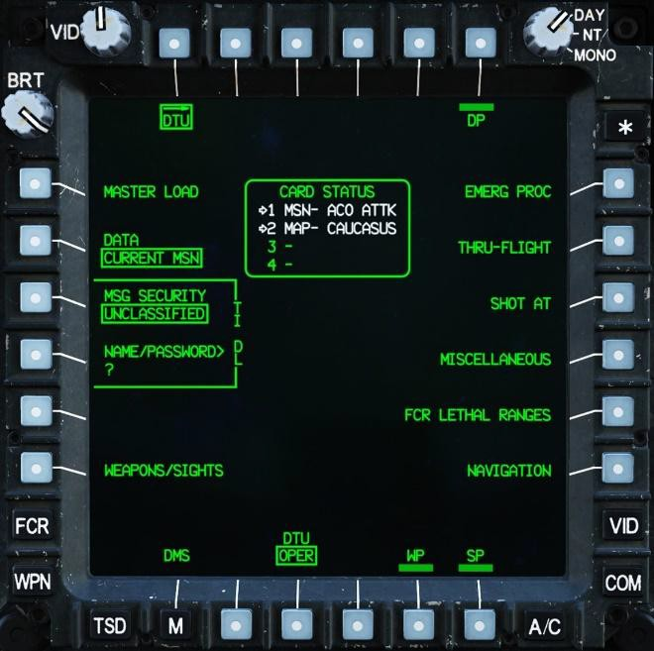
Mission 2 Radios Datalink Config Presets
FCR Lethal Ranges
Miscellaneous
Shot At
MWOD
SOI
Navigation
High Frequency
Weapons & Sights

The MWOD, SOI, High Frequency, Emergency Procedures, Shot At, FCR Lethal Ranges, and Navigation partitions are not implemented.

Mission 1/2 Database (MISSION 1/MISSION 2)
Each DTC Mission (MISSION 1 or MISSION 2) contains the majority of the data that will be edited on a per-mission basis.

- WPTHZ Waypoints and Hazards 01-50.
- CTRLM Control Measures 51-99.
- TGT/THRT Targets and Threats 01-50.
- ROUTES Routes 1-10.
- LINES Battlefield Lines 01-15.
- AREAS Engagement Areas 01-12.
- ZONES Priority Fire/No Fire Zones.
- ADF Automatic Direction Finder presets.

Due to limitations of the onboard memory, only one entire Mission may be uploaded from the DTC at any time. However, if necessary, individual Mission files from either MISSION 1 or MISSION 2 may be selectively uploaded to combine data from each Mission, such as uploading TGT/THRT file from MISSION 1 and the ZONES file from MISSION 2.

Waypoints and Hazards (WPTHZ)
The WPTHZ tab allows the user to input Waypoint/Hazard points for navigation or depicting low-altitude hazards that may be encountered during the mission.

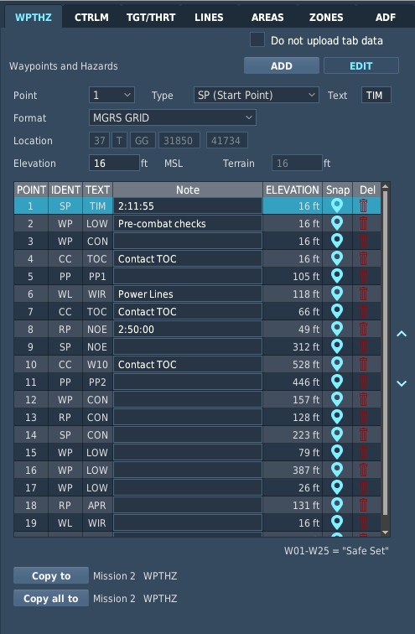
5. Point Table
6. Index Arrows
4. Point Parameters
8. Copy all to Button
7. Copy to Button
4. EDIT Button
3. ADD Button
1. Do not upload tab data
- Do not upload tab data. When this option is checked (default state), the contents of this tab will not be uploaded from the DTC. The tab will be disabled and cannot be modified while this option is checked.
- ADD Button. When pressed, the mouse pointer may be used to add a new Waypoint/Hazard point by left-clicking on the map at the desired point location. A new point will be created within the first available index in the table below, with the point elevation defaulting to the elevation of the terrain at that location. If 50 Waypoint/Hazard points are already present, the button is disabled.
- EDIT Button. When pressed, the mouse pointer may be used to select or drag Waypoint/Hazard points 1-50 on the map to modify their location. Changing the location of an existing point will not alter its elevation.
- Point Parameters. Displays the parameters of the selected Waypoint/Hazard point.
  - Point. Selects the point for which parameters are being displayed/edited. Alternatively, a point may be selected by left-clicking within the table or the map while the EDIT button is pressed.
  - Type. Selects the Waypoint/Hazard symbol that will be used to display the point on the TSD page.
  - Text. Displays/edits the 3-character free text of the point.
  - Format. Selects the coordinate format in which the Location data will be displayed.
  - Location. Displays the coordinates of the selected point.
  - Elevation. Displays/edits the elevation (in feet above Mean Sea Level, MSL) of the selected point.
  - Terrain. Displays the elevation (in feet above Mean Sea Level, MSL) of the terrain at the location of the selected point, as a reference when editing the Elevation data.

- Point Table. Displays the database of Waypoint/Hazard points 1-50. The point for which parameters are being displayed and edited is highlighted within the table.
  - POINT. Displays the index number of the point within the Waypoint/Hazard database.
  - IDENT. Displays the Waypoint/Hazard symbol that will be used to display the point on the TSD.
  - TEXT. Displays the 3-character free text of the point.
  - Note. Displays additional information about the point. This information is for reference only when using the DTC Manager and is not uploaded from the DTC into the onboard memory.
  - ELEVATION. Displays the elevation (in feet above Mean Sea Level, MSL) of the point.
  - Snap. When the blue “pin” icon within this column is selected, the map will be re-centered on the highlighted point.
  - Del. When the red “trash can” icon within this column is selected, the highlighted point will be removed from the point table.
- Index Arrows. When the up or down arrows are pressed, the selected point is moved upward or downward, respectively, within the Waypoint/Hazard point indexes, allowing points to be re-ordered if necessary.
- Copy to Button. When pressed, the selected Waypoint/Hazard point (highlighted within the table) will be copied to the WPTHZ tab in Mission 2, overwriting the corresponding Waypoint/Hazard index number. Likewise, pressing this button when the WPTHZ tab in Mission 2 is displayed will copy the selected Waypoint/Hazard point to the WPTHZ tab in Mission 1.
- Copy all to Button. When pressed, the contents of the entire WPTHZ tab in Mission 1 will be copied to the WPTHZ tab in Mission 2, overwriting all Waypoint/Hazard points in Mission 2. Likewise, pressing this button when the WPTHZ tab in Mission 2 is displayed will copy the entire WPTHZ tab to Mission 1.

Control Measures (CTLRM)
The CTRLM tab allows the user to input Control Measure points for depicting friendly and enemy units, airfields, and other points that may be used for coordinating with other AH-64Ds or friendly forces during a mission.

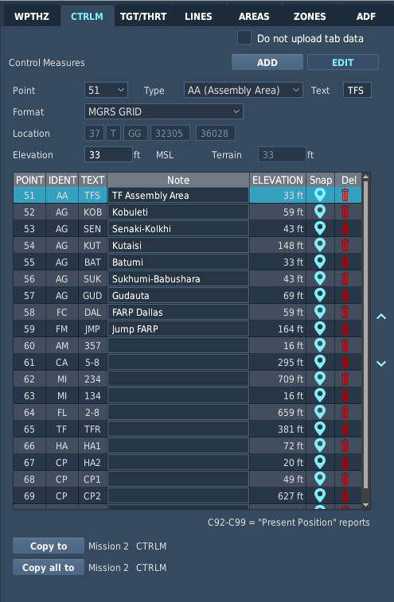
5. Point Table
6. Index Arrows
4. Point Parameters
8. Copy all to Button
7. Copy to Button
4. EDIT Button
3. ADD Button
1. Do not upload tab data
- Do not upload tab data. When this option is checked (default state), the contents of this tab will not be uploaded from the DTC. The tab will be disabled and cannot be modified while this option is checked.
- ADD Button. When pressed, the mouse pointer may be used to add a new Control Measure point by left-clicking on the map at the desired point location. A new point will be created within the first available index in the table below, with the point elevation defaulting to the elevation of the terrain at that location. If 49 Control Measure points are already present, the button is disabled.
- EDIT Button. When pressed, the mouse pointer may be used to select or drag Control Measure points 51-99 on the map to modify their location. Changing the location of an existing point will not alter its elevation.
- Point Parameters. Displays the parameters of the selected Control Measure point.
  - Point. Selects the point for which parameters are being displayed/edited. Alternatively, a point may be selected by left-clicking within the table or the map while the EDIT button is pressed.
  - Type. Selects the Control Measure symbol that will be used to display the point on the TSD page.
  - Text. Displays/edits the 3-character free text of the point.
  - Format. Selects the coordinate format in which the Location data will be displayed.
  - Location. Displays the coordinates of the selected point.
  - Elevation. Displays/edits the elevation (in feet above Mean Sea Level, MSL) of the selected point.
  - Terrain. Displays the elevation (in feet above Mean Sea Level, MSL) of the terrain at the location of the selected point, as a reference when editing the Elevation data.

- Point Table. Displays the database of Control Measure points 51-99. The point for which parameters are being displayed and edited is highlighted within the table.
  - POINT. Displays the index number of the point within the Control Measure database.
  - IDENT. Displays the Control Measure symbol that will be used to display the point on the TSD.
  - TEXT. Displays the 3-character free text of the point.
  - Note. Displays additional information about the point. This information is for reference only when using the DTC Manager and is not uploaded from the DTC into the onboard memory.
  - ELEVATION. Displays the elevation (in feet above Mean Sea Level, MSL) of the point.
  - Snap. When the blue “pin” icon within this column is selected, the map will be re-centered on the highlighted point.
  - Del. When the red “trash can” icon within this column is selected, the highlighted point will be removed from the point table.
- Index Arrows. When the up or down arrows are pressed, the selected point is moved upward or downward, respectively, within the Control Measure point indexes, allowing points to be re-ordered if necessary.
- Copy to Button. When pressed, the selected Control Measure point (highlighted within the table) will be copied to the CTRLM tab in Mission 2, overwriting the corresponding Control Measure index number. Likewise, pressing this button when the CTRLM tab in Mission 2 is displayed will copy the selected Control Measure point to the CTRLM tab in Mission 1.
- Copy all to Button. When pressed, the contents of the entire CTRLM tab in Mission 1 will be copied to the CTRLM tab in Mission 2, overwriting all Control Measure points in Mission 2. Likewise, pressing this button when the CTRLM tab in Mission 2 is displayed will copy the entire CTRLM tab to Mission 1.

Targets and Threats (TGT/THRT)
The TGT/THRT tab allows the user to input Target/Threat points depicting pre-planned target locations or locations of known or suspected enemy air defense units that may be encountered during the mission.
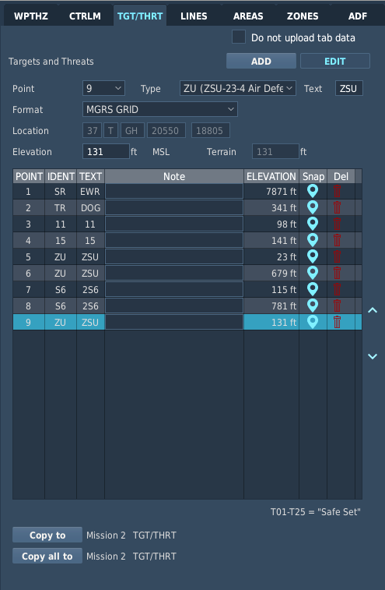
5. Point Table
6. Index Arrows
4. Point Parameters
8. Copy all to Button
7. Copy to Button
4. EDIT Button
3. ADD Button
1. Do not upload tab data
- Do not upload tab data. When this option is checked (default state), the contents of this tab will not be uploaded from the DTC. The tab will be disabled and cannot be modified while this option is checked.
- ADD Button. When pressed, the mouse pointer may be used to add a new Target/Threat point by left-clicking on the map at the desired point location. A new point will be created within the first available index in the table below, with the point elevation defaulting to the elevation of the terrain at that location. If 50 Target/Threat points are already present, the button is disabled.
- EDIT Button. When pressed, the mouse pointer may be used to select or drag Target/Threat points 1-50 on the map to modify their location. Changing the location of an existing point will not alter its elevation.
- Point Parameters. Displays the parameters of the selected Target/Threat point.
  - Point. Selects the point for which parameters are being displayed/edited. Alternatively, a point may be selected by left-clicking within the table or the map while the EDIT button is pressed.
  - Type. Selects the Target/Threat symbol that will be used to display the point on the TSD page.
  - Text. Displays/edits the 3-character free text of the point.
  - Format. Selects the coordinate format in which the Location data will be displayed.
  - Location. Displays the coordinates of the selected point.
  - Elevation. Displays/edits the elevation (in feet above Mean Sea Level, MSL) of the selected point.
  - Terrain. Displays the elevation (in feet above Mean Sea Level, MSL) of the terrain at the location of the selected point, as a reference when editing the Elevation data.

- Point Table. Displays the database of Target/Threat points 1-50. The point for which parameters are being displayed and edited is highlighted within the table.
  - POINT. Displays the index number of the point within the Target/Threat database.
  - IDENT. Displays the Target/Threat symbol that will be used to display the point on the TSD.
  - TEXT. Displays the 3-character free text of the point.
  - Note. Displays additional information about the point. This information is for reference only when using the DTC Manager and is not uploaded from the DTC into the onboard memory.
  - ELEVATION. Displays the elevation (in feet above Mean Sea Level, MSL) of the point.
  - Snap. When the blue “pin” icon within this column is selected, the map will be re-centered on the highlighted point.
  - Del. When the red “trash can” icon within this column is selected, the highlighted point will be removed from the point table.
- Index Arrows. When the up or down arrows are pressed, the selected point is moved upward or downward, respectively, within the Target/Threat point indexes, allowing points to be re-ordered if necessary.
- Copy to Button. When pressed, the selected Target/Threat point (highlighted within the table) will be copied to the TGT/THRT tab in Mission 2, overwriting the corresponding Target/Threat index number. Likewise, pressing this button when the TGT/THRT tab in Mission 2 is displayed will copy the selected Target/Threat point to the TGT/THRT tab in Mission 1.
- Copy all to Button. When pressed, the contents of the entire TGT/THRT tab in Mission 1 will be copied to the TGT/THRT tab in Mission 2, overwriting all Target/Threat points in Mission 2. Likewise, pressing this button when the TGT/THRT tab in Mission 2 is displayed will copy the entire TGT/THRT tab to Mission 1.

Battlefield Lines (LINES)
The LINES tab allows the user to plot battlefield line graphics for display on the TSD page, such as friendly or enemy controlled territory, phase lines, or any other type of linear boundary that may be used to coordinate the actions of friendly forces during the mission.

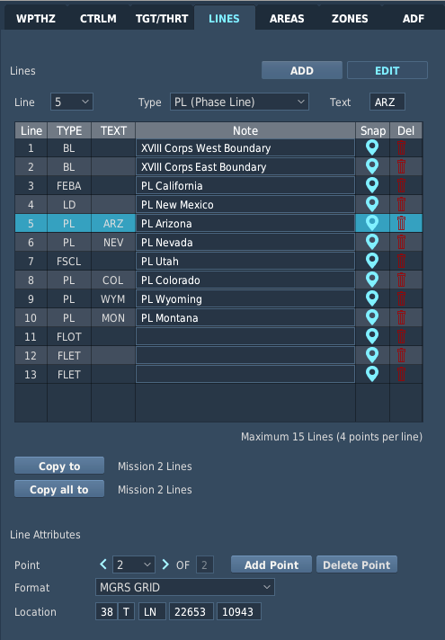
7. Line Attributes
4. Line Table
3. Line Parameters
6. Copy all to Button
5. Copy to Button
2. EDIT Button
1. ADD Button
- ADD Button. When pressed, the mouse pointer may be used to add a new line by left-clicking on the map at the desired locations of the first and second points of the line to create the first segment. A new line will be created within the first available index in the table below. If 15 lines are present, the button is disabled.
- EDIT Button. When pressed, the mouse pointer may be used to select or drag individual line points on the map to modify their location.
- Line Parameters. Displays the parameters of the selected line.
  - Point. Selects the line for which parameters are being displayed/edited. Alternatively, a line may be selected by left-clicking within the table or the map while the EDIT button is pressed.
  - Type. Selects the type of Battlefield Line that will be displayed on the TSD page.
  - Text. Displays the text identifier of the line. If the selected line type is set to “PL (Phased Line)”, three
free text characters may be added.
- Line Table. Displays the database of Lines 1-15. The line for which parameters are being displayed and edited is highlighted within the table.
  - Line. Displays the index number of the line within the database.
  - TYPE. Displays the type of line that will be displayed on the TSD page.
  - TEXT. Displays the 3-character free text of the line.
  - Note. Displays additional information about the line. This information is for reference only when using the DTC Manager and is not uploaded from the DTC into the onboard memory.

  - Snap. When the blue “pin” icon within this column is selected, the map will be re-centered on the highlighted line.
  - Del. When the red “trash can” icon within this column is selected, the highlighted line will be removed from the line table.
- Copy to Button. When pressed, the selected line (highlighted within the table) will be copied to the LINES tab in Mission 2, overwriting the corresponding Line index number. Likewise, pressing this button when the LINES tab in Mission 2 is displayed will copy the selected line to the LINES tab in Mission 1.
- Copy all to Button. When pressed, the contents of the entire LINES tab in Mission 1 will be copied to the LINES tab in Mission 2, overwriting all lines in Mission 2. Likewise, pressing this button when the LINES tab in Mission 2 is displayed will copy the entire LINES tab to Mission 1.
- Line Attributes. Displays the parameters of the selected point within the selected line.
  - Point. Selects the line point for which the location attribute is being displayed/edited. Alternatively, a point may be selected by left-clicking on the map while the EDIT button is pressed.
  - Add Point button. If the selected line only consists of 2 or 3 points, adds an additional point at the end of the line. If the line consists of 4 points, the button is disabled.
  - Delete Point button. If the selected line consists of 3 or 4 points, deletes the selected point from the line. If the line consists of only 2 points, the button is disabled.
  - Format. Selects the coordinate format in which the Location data will be displayed.
  - Location. Displays the coordinates of the selected line point.

Engagement Areas (AREAS)
The AREAS tab allows the user to plot engagement area graphics for display on the TSD page, which designate areas of terrain in which the AH-64D team and/or other friendly units intend to mass fires on enemy forces during the mission.

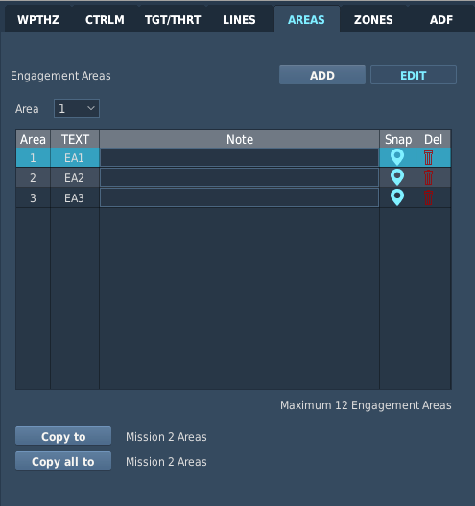
4. Area Table
6. Copy all to Button
5. Copy to Button
3. Area Select
2. EDIT Button
1. ADD Button
- ADD Button. When pressed, the mouse pointer may be used to add a new Engagement Area by left-clicking on the map at the desired locations of the two opposing corners to create the area. A new quadrilateral area will be created within the first available index in the table below. If 12 areas are already present, the button is disabled.
- EDIT Button. When pressed, the mouse pointer may be used to select or drag individual area corners on the map to modify their location.
- Area Select. Selects the area for which parameters are being displayed. Alternatively, an area may be selected by left-clicking within the table or the map while the EDIT button is pressed.
- Area Table. Displays the database of Engagement Areas 1-12. The area for which parameters are being displayed and edited is highlighted within the table.
  - Area. Displays the index number of the area within the database.
  - TEXT. Displays the text identifier of the area.
  - Note. Displays additional information about the area. This information is for reference only when using the DTC Manager and is not uploaded from the DTC into the onboard memory.
  - Snap. When the blue “pin” icon within this column is selected, the map will be re-centered on the highlighted area.
  - Del. When the red “trash can” icon within this column is selected, the highlighted area will be removed from the area table.
- Copy to Button. When pressed, the selected area (highlighted within the table) will be copied to the AREAS tab in Mission 2, overwriting the corresponding Area index number. Likewise, pressing this button when the AREAS tab in Mission 2 is displayed will copy the selected areas to the AREAS tab in Mission 1.
- Copy all to Button. When pressed, the contents of the entire AREAS tab in Mission 1 will be copied to the AREAS tab in Mission 2, overwriting all areas in Mission 2. Likewise, pressing this button when the AREAS tab in Mission 2 is displayed will copy the entire AREAS tab to Mission 1.

Priority Fire/No Fire Zones (ZONES)
The ZONES tab allows the user to plot Priority Fire Zones (PFZ) and/or No Fire Zones (NFZ) for display on the TSD page, as pre-planned fire support control measures to distribute or restrict fires within the AH-64D team during the mission.

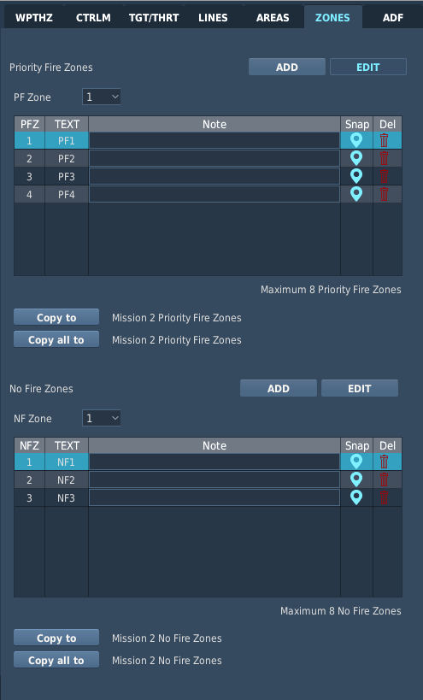
8. NF Zone Table
4. PF Zone Table
6. Copy all to Button
5. Copy to Button
2. EDIT Button
7. NF Zone Select
1. ADD Button
6. Copy all to Button
5. Copy to Button
2. EDIT Button
3. PF Zone Select
1. ADD Button
- ADD Button. When pressed, the mouse pointer may be used to add a new zone by left-clicking on the map at the desired locations of the two opposing corners to create the zone. A new quadrilateral zone will be created within the first available index in the table below. If 8 zones of the corresponding type (PF Zone or NF Zone) are already present, the button is disabled.
- EDIT Button. When pressed, the mouse pointer may be used to select or drag individual zone corners on the map to modify their location.
- PF Zone Select. Selects the PF zone for which parameters are being displayed. Alternatively, a PF zone may be selected by left-clicking within the table or the map while the EDIT button is pressed.
- PF Zone Table. Displays the database of Priority Fire Zones 1-8. The PF zone for which parameters are being displayed and edited is highlighted within the table.
  - PFZ. Displays the index number of the PF zone within the database.
  - TEXT. Displays the text identifier of the PF zone.
  - Note. Displays additional information about the PF zone. This information is for reference only when using the DTC Manager and is not uploaded from the DTC into the onboard memory.
  - Snap. When the blue “pin” icon within this column is selected, the map will be re-centered on the highlighted PF zone.

  - Del. When the red “trash can” icon within this column is selected, the highlighted PF zone will be removed from the area table.
- Copy to Button. When pressed, the selected zone (highlighted within the table) will be copied to the ZONES tab in Mission 2, overwriting the corresponding zone index number. Likewise, pressing this button when the ZONES tab in Mission 2 is displayed will copy the selected zone to the ZONES tab in Mission 1.
- Copy all to Button. When pressed, the contents of the entire PF Zone table or NF Zone table in Mission 1 will be copied to the ZONES tab in Mission 2, overwriting all PF zones or NF zones, respectively, in Mission
2. Likewise, pressing this button when the ZONES tab in Mission 2 is displayed will copy the entire PF Zone table or NF Zone table to Mission 1.
- NF Zone Select. Selects the NF zone for which parameters are being displayed. Alternatively, an NF zone may be selected by left-clicking within the table or the map while the EDIT button is pressed.
- NF Zone Table. Displays the database of No Fire Zones 1-8. The NF zone for which parameters are being displayed and edited is highlighted within the table.
  - NFZ. Displays the index number of the NF zone within the database.
  - TEXT. Displays the text identifier of the NF zone.
  - Note. Displays additional information about the NF zone. This information is for reference only when using the DTC Manager and is not uploaded from the DTC into the onboard memory.
  - Snap. When the blue “pin” icon within this column is selected, the map will be re-centered on the highlighted NF zone.
  - Del. When the red “trash can” icon within this column is selected, the highlighted NF zone will be removed from the area table.

AN/ARN-149 ADF Presets (ADF)
The ADF tab allows the user to input up to 10 preset NDB frequencies that may be tuned via the INST Utility sub-page, for limited radio navigation within Instrument Meteorological Conditions (IMC).

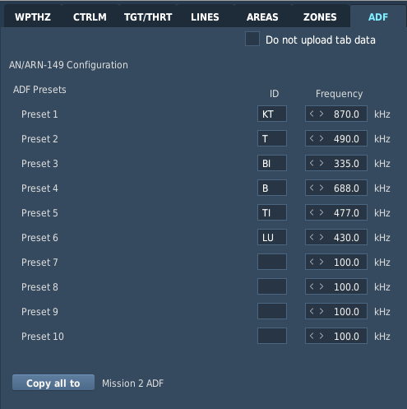
2. Preset Frequencies
3. Copy all to Button
1. Do not upload tab data
- Do not upload tab data. When this option is checked (default state), the contents of this tab will not be uploaded from the DTC. The tab will be disabled and cannot be modified while this option is checked.
- ADF Presets. Displays the beacon identification and frequencies assigned to each ADF preset.
  - Preset. Displays the preset number 1-10.
  - ID. Displays/edits the 3-letter identifier for the selected ADF preset. Numbers or other characters will not be accepted.
NOTE: The morse code equivalent of the preset ID is displayed in the ADF status window on the TSD Instruments sub-page to assist in identifying the tuned NDB station to which the ADF Bearing Pointer is indicating. If the ID of the ADF preset does not match the published NDB station identifier, the morse code in the ADF status window will not match the morse code audio that is broadcast over the NDB frequency and identification of the tuned NDB station will not be possible.
  - Frequency. Displays/edits the beacon frequency assigned to the corresponding ADF preset. Valid frequencies range from 100.0 to 2199.5 kHz, in 0.1 kHz increments.
- Copy all to Button. When pressed, the contents of the entire ADF tab in Mission 1 will be copied to the ADF tab in Mission 2, overwriting all ADF presets in Mission 2. Likewise, pressing this button when the ADF tab in Mission 2 is displayed will copy the entire ADF tab to Mission 1.

Mission 1/2 Routes (MISSION 1/MISSION 2)
The Mission 1 Routes and Mission 2 Routes contain the remainder of the data that is uploaded within the respective Mission partitions (MISSION 1 and MISSION 2).
Mission Routes (1-10)
The Route tabs allow the user to assign Waypoints, Hazards, or Control Measures to any of the 10 route sequences on the TSD Route Menu sub-page, and provides rudimentary flight planning for coordinating the speed and timing of the AH-64D team along each route during the mission.

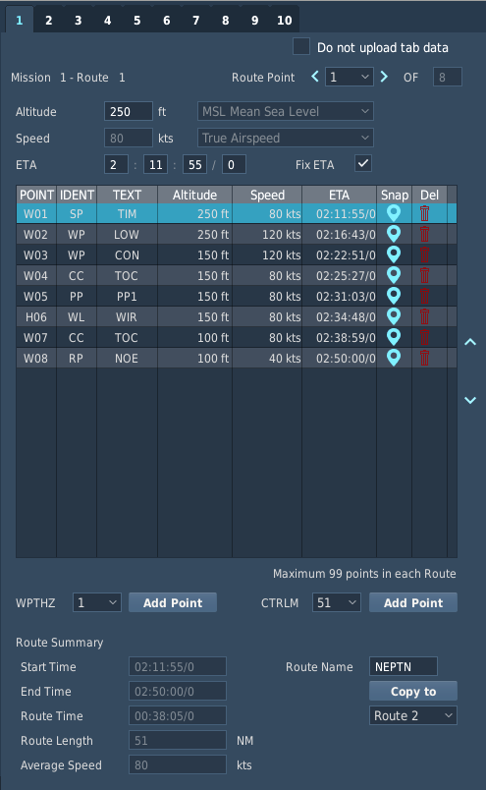
9. Route Summary
4. Route Table
5. Index Arrows
3. Route Leg Parameters
12. Copy to Route Select
11. Copy to Button
10. Route Name
8. Add Point Button
7. CTRLM Point Select
6. WPTHZ Point Select
2. Route Point Select
1. Do not upload tab data
- Do not upload tab data. When this option is checked (default state), the contents of this tab will not be uploaded from the DTC. The tab will be disabled and cannot be modified while this option is checked.
- Route Point Select. When the left or right arrows are pressed, the selected route point is decremented backward or incremented forward, respectively, within the route sequence.
- Route Leg Parameters. Displays the flight parameters to be flown from the preceding route point to the selected route point.
  - Altitude. Displays/edits the planned flight altitude (in feet) above mean sea level (MSL) to the selected route point.
  - Speed. Displays/edits the planned ground speed (in knots) to the selected route point.
  - ETA. Displays/edits the estimated time of arrival (in HH:MM:SS/Day format) over the selected route point, based on the planned speed of the route leg and each preceding leg within the route sequence.

  - Fix Time. When this option is checked, the user may edit the selected route leg by time rather than by speed. The ETA data field will become editable and the Speed data field will automatically update based on the time that is input into the ETA data fields.
- Route Table. Displays the route sequence by each route leg. The route point for which parameters are being displayed and edited is highlighted within the table.
  - POINT. Displays the index number of the point within the navigation database.
  - IDENT. Displays the Waypoint/Hazard or Control Measure symbol that will be used to display the point on the TSD.
  - TEXT. Displays the 3-character free text of the point.
  - Altitude. Displays the planned flight altitude (in feet) of the route leg.
  - Speed. Displays the planned speed (in knots) of the route leg.
  - ETA. Displays the estimated time of arrival (in HH:MM:SS/Day format) over the selected route point.
  - Snap. When the blue “pin” icon within this column is selected, the map will be re-centered on the highlighted point.
  - Del. When the red “trash can” icon within this column is selected, the highlighted point will be removed from the navigation route.
- Index Arrows. When the up or down arrows are pressed, the selected point is moved upward or downward, respectively, within the route sequence, allowing route points to be re-ordered if necessary.
- WPTHZ Point Select. Selects the Waypoint/Hazard index number to be added to the route sequence when the corresponding Add Point button is pressed.
- CTRLM Point Select. Selects the Control Measure index number to be added to the route sequence when the corresponding Add Point button is pressed.
- Add Point Button. When pressed, the selected Waypoint/Hazard or Control Measure point will be added to the route sequence. If 99 points are already present within the route sequence, the button is disabled.
- Route Summary. Displays a summary of the entire route sequence, based on the ETA of the first point and the parameters of each subsequent route leg within the sequence.
  - Start Time. Displays the clock time (in HH:MM:SS/Day format) at which the aircraft is planned to arrive over the first point in the route sequence.
  - End Time. Displays the clock time (in HH:MM:SS/Day format) at which the aircraft should arrive over the final point in the route sequence, assuming the aircraft arrives over the first point as planned and there are no deviations from the planned route.
  - Route Time. Displays the total elapsed time (in HH:MM:SS/Day format) that is required for the aircraft to fly the route, assuming no deviations from the planned route.
  - Route Length. Displays the total distance of the route in nautical miles (NM).
  - Average Speed. Displays the average speed of the aircraft along the planned route in knots (kts).
- Route Name. Displays/edits the 5-character name of the route displayed on the TSD Route and TSD Route Menu sub-pages.
- Copy to Button. When pressed, the displayed route sequence will be copied to the route sequence selected within the data field below, overwriting the corresponding route sequence in the same Mission.
- Copy to Route Select. Selects the route that will be overwritten by the displayed route sequence when the Copy to button is pressed.

Radio Settings (RADIOS)
The Radio Settings initialize the AH-64D’s radios to the configurations stored within the DTC, but do not change
any preset frequencies or datalink settings.
Radio and Transponder Settings (SETTINGS)
The SETTINGS tab allows the user to assign a preset or manual frequency to each radio that will be tuned upon upload of the RADIOS partition from the DTC via the DMS Data Transfer Unit sub-page, edit the settings of the UHF and FM radios, or configure the APX-118 transponder settings.

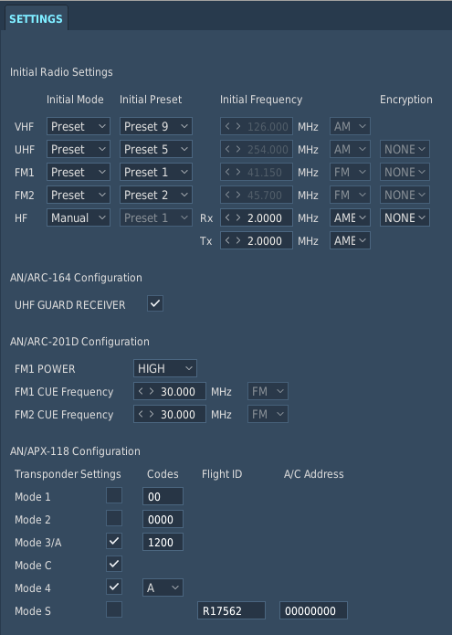
4. Transponder Configuration
3. FM1/FM2 Configuration
1. Initial Radio Settings
2. UHF GUARD RECEIVER
- Initial Radio Settings. Displays the selected presets or manually-input frequencies to which the radios will be initialized upon upload of the DTC RADIOS partition.
  - Initial Mode. Selects the initial tuning mode of the corresponding radio.
    - Preset. The radio will be tuned to the COM preset selected under the Initial Preset column.
    - Manual. The radio will be tuned to the frequency input under the Initial Frequency column.
  - Initial Preset. Selects the COM preset to which the radio will be tuned.
  - Initial Frequency. Displays/edits the frequency to which the radio will be tuned.
    - VHF. Displays/edits the initial frequency to which the VHF radio will be tuned. Valid frequencies range from 108.000-115.975 MHz and 116.000-151.975 MHz, in 0.025 MHz increments.
    - UHF. Displays/edits the initial frequency to which the UHF radio will be tuned.. Valid frequencies range from 225.000-399.975 MHz, in 0.025 MHz increments.
    - FM1. Displays/edits the initial frequency to which the FM1 radio will be tuned. Valid frequencies range from 30.000-87.975 MHz, in 0.025 MHz increments.
    - FM2. Displays/edits the initial frequency to which the FM2 radio will be tuned. Valid frequencies range from 30.000-87.975 MHz, in 0.025 MHz increments.

    - HF Rx. Displays/edits the initial receive frequency and emission mode to which the HF radio will be tuned. Valid frequencies range from 2.0000-29.9999 MHz, in 0.0001 MHz increments.
    - HF Tx. Displays/edits the initial transmit frequency and emission mode to which the HF radio will be tuned. Valid frequencies range from 2.0000-29.9999 MHz, in 0.0001 MHz increments.
    - Encryption. Selects the initial encryption setting. (N/I)
- UHF GUARD RECEIVER. When this option is checked, the dedicated GUARD receiver of the UHF radio will be enabled, permitting the crew to monitor 243.0 MHz in addition to the primary frequency to which the radio is tuned.
- FM1/FM2 Configuration. Displays the configuration to which the AN/ARC-201D SINGCGARS radios will be initialized upon upload of the DTC RADIOS partition.
  - FM1 POWER. Selects the power output setting of the IFM amplifier.
  - FM1 CUE Frequency. Displays/edits the “Cue” frequency assigned to the FM1 radio. Valid frequencies range from 30.000-87.975 MHz, in 0.025 MHz increments.
  - FM2 CUE Frequency. Displays/edits the “Cue” frequency assigned to the FM2 radio. Valid frequencies range from 30.000-87.975 MHz, in 0.025 MHz increments.
- Transponder Configuration. Displays the configuration to which the AN/APX-118(V) transponder will be initialized upon upload of the DTC RADIOS partition. (N/I)
  - Transponder Settings. When the corresponding transponder mode option is checked, replies from the respective transponder mode are enabled.
  - Codes. Displays/edits the corresponding reply code.
    - Mode 1. Valid range is 00-73.
    - Mode 2. Valid range for each digit is 0-7.
    - Mode 3/A. Valid range for each digit is 0-7.
    - Mode 4. Selects the first (A) or second (B) encrypted IFF code.
  - Flight ID. Displays/edits the 8-character Mode S identifier.
  - A/C Address. Displays/edits the 8-digit Mode S aircraft address. Valid range for each digit is 0-7.

Communication Presets (PRESETS)
The COM Presets contain the AH-64D team’s communications plan for the mission, to include pre-composed text messages to facilitate command and control or coordinate specific actions during the mission.
COM Preset Settings (1-10)

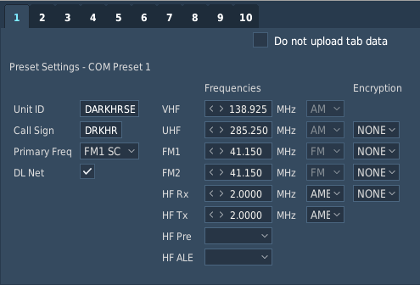
The top row of numbered tabs allow the user to edit the data within the 10 COM presets, including the Unit ID, Callsign, frequencies, and whether DATALINK protocols are enabled on the COM Modem sub-page for the preset.
1. Do not upload tab data

- Do not upload tab data. When this option is checked (default state), the contents of this tab will not be uploaded from the DTC. The tab will be disabled and cannot be modified while this option is checked.
2. COM Preset Settings
- COM Preset Settings. Displays the selected COM preset data and enables/disables DATALINK protocols across the preset network.
  - Unit ID. Displays/edits the 8-character Unit ID displayed on the COM page and EUFD Preset list.
  - Call Sign. Displays/edits the 5-character Call Sign displayed within the Radio Status Area on the EUFD.
  - Primary Freq. Selects the primary frequency and radio for the COM preset. The primary designation does not affect the function of any radio equipment or how the preset is assigned to a specific radio.
  - DL Net. When this option is checked, DATALINK protocol is enabled for the COM preset. This option is only available for COM Presets 1-8 and is not displayed on tabs 9 and 10.
  - Frequencies. Displays the frequencies and emission modes utilized by the COM preset when tuned to the corresponding radio.
    - VHF. Displays/edits the VHF-AM frequency assigned to the COM preset. Valid frequencies range from 108.000-115.975 MHz and 116.000-151.975 MHz, in 0.025 MHz increments.
    - UHF. Displays/edits the UHF-AM frequency assigned to the COM preset. Valid frequencies range from 225.000-399.975 MHz, in 0.025 MHz increments.
    - FM1. Displays/edits the first VHF-FM frequency assigned to the COM preset. Valid frequencies range from 30.000-87.975 MHz, in 0.025 MHz increments.
    - FM2. Displays/edits the second VHF-FM frequency assigned to the COM preset. Valid frequencies range from 30.000-87.975 MHz, in 0.025 MHz increments.
    - HF Rx. Displays/edits the HF receive frequency and emission mode assigned to the COM preset. Valid frequencies range from 2.0000-29.9999 MHz, in 0.0001 MHz increments.
    - HF Tx. Displays/edits the HF transmit frequency and emission mode assigned to the COM preset. Valid frequencies range from 2.0000-29.9999 MHz, in 0.0001 MHz increments.
    - HF Pre. Not implemented.
    - HF ALE. Not implemented.
  - Encryption. Selects the encryption settings for the COM preset. (N/I)

MPS Text Messages (1-10)
The bottom row of numbered tabs allow the user to edit the 10 pre-composed text messages that may be transmitted across the datalink network from the COM MSG-SEND Text sub-page.

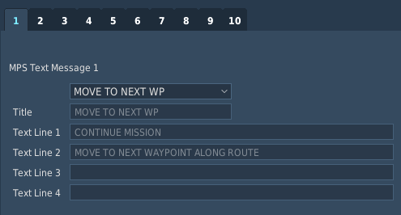
5. Message Lines
4. Message Title
3. Default Message Select
- Default Message Select. Selects the default text message assigned to MPS Text Message. If the Default
Message selection is set to “Custom”, a custom message title and text lines may be input.
- Message Title. Displays/edits the message title of the corresponding MPS Text Message displayed on the COM MSG SEND Text sub-page. The title may be a maximum of 24 characters may be input.
- Message Lines. Displays/edits the 4-line message contents of the corresponding MPS Text Message. Each message line may contain a maximum of 44 characters may be input.

Weapon Settings/Laser Codes (WEAPONS/SIGHTS)
The Weapons/Sights data contains the default laser settings for the TADS and AGM-114K missiles, and the default weapon settings for each crewstation.
Missile Channels and Weapon Settings (WEAPON SETTINGS)
The WEAPON SETTINGS tab allows the user to configure the Pilot’s and CPG’s default gun and rocket settings,
manual range settings, acquisition sources, and the missile channels for the AGM-114K laser-guided missiles.

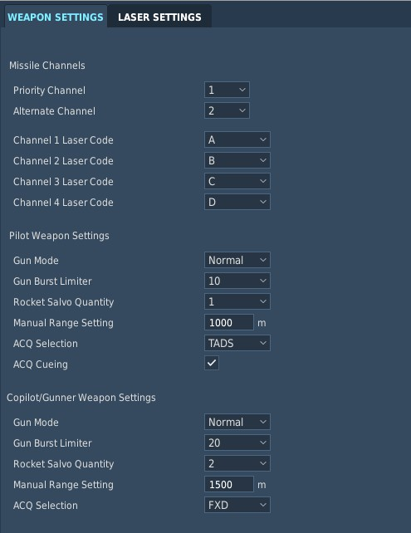
3. Copilot/Gunner Weapon Settings
2. Pilot Weapon Settings
1. Missile Channels
- Missile Channels. Configures the missile channels and laser codes assigned to the AGM-114K semi-active laser-homing (SAL) missiles on the WPN page.
  - Priority Channel. Selects the Priority SAL missile channel, 1-4.
  - Alternate Channel. Selects the Alternate SAL missile channel, 1-4.
  - Channel 1 Laser Code. Selects the laser code assigned to SAL missile channel 1.
  - Channel 2 Laser Code. Selects the laser code assigned to SAL missile channel 2.
  - Channel 3 Laser Code. Selects the laser code assigned to SAL missile channel 3.
  - Channel 4 Laser Code. Selects the laser code assigned to SAL missile channel 4.
- Pilot Weapon Settings. Configures the Pilot-specific settings on the WPN page.
  - Gun Mode. Selects the gun mode as Normal (NORM) or Fixed (FXD).
  - Gun Burst Limiter. Selects the gun burst limiter as 10, 20, 50, 100, or ALL.
  - Rocket Salvo Quantity. Selects the rocket salvo quantity as 1, 2, 4, 8, 12, 24, or ALL.
  - Manual Range Setting. Displays/edits the manual range (MANRNG) setting, between 100 and 50,000 meters in 1-meter increments.
  - ACQ Selection. Selects the Pilot’s acquisition source.

  - ACQ Cueing. When this option is checked, cueing symbology to the Pilot’s acquisition source is enabled on the WPN Utility page, displaying the Cued LOS Reticle and Cueing Dots within the HMD symbology.
- Copilot/Gunner Weapon Settings. Configures the CPG-specific settings on the WPN page.
  - Gun Mode. Selects the gun mode as Normal (NORM) or Fixed (FXD).
  - Gun Burst Limiter. Selects the gun burst limiter as 10, 20, 50, 100, or ALL.
  - Rocket Salvo Quantity. Selects the rocket salvo quantity as 1, 2, 4, 8, 12, 24, or ALL.
  - Manual Range Setting. Displays/edits the manual range (MANRNG) setting, between 100 and 50,000 meters in 1-meter increments.
  - ACQ Selection. Selects the CPG’s acquisition source.

Laser Codes/Frequencies (LASER SETTINGS)

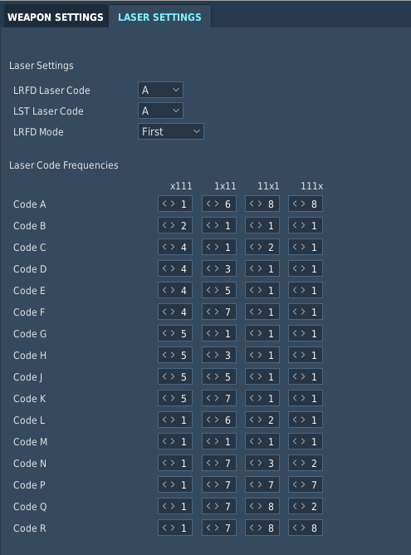
The LASER SETTINGS tab allows the user to assign laser codes to the TADS laser rangefinder/designator (LRFD) and laser spot tracker (LST), or edit the 16 laser pulse repetition frequencies on the WPN Frequency sub-page.
1. Laser Settings

- Laser Settings. Configures the TADS laser settings on the WPN page and WPN Code sub-page.
2. Laser Code Frequencies
  - LRFD Laser Code. Selects the laser code assigned to the TADS laser rangefinder/designator (LRFD).
  - LST Laser Code. Selects the laser code assigned to the TADS laser spot tracker (LST).
  - LRFD Mode. Selects the TADS LRFD laser ranging setting.
- Laser Code Frequencies. Selects the first, second, third, and fourth digit of each preset frequencies of the laser codes on the WPN Frequency sub-page.

ASE Settings/Threat Tables/Performance Data (MISCELLANEOUS)
The Miscellaneous data contains Aircraft Survivability Equipment (ASE) settings, radar/laser threat priorities for the APR-39/AVR-2 Radar/Laser Warning System (RLWR), performance planning data for the PERF page, and the default operating mode of the anti-ice system.
Aircraft Survivability Equipment Settings (ASE)
The ASE tab allows the user to configure the Pilot’s and CPG’s ASE Autopage settings, the chaff dispensing mode

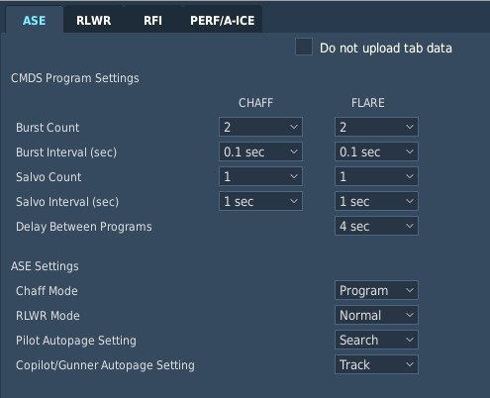
and program, and the CMWS flare dispensing program.
2. CMDS Program Settings
1. Do not upload tab data

- Do not upload tab data. When this option is checked (default state), the contents of this tab will not be uploaded from the DTC. The tab will be disabled and cannot be modified while this option is checked.
3. ASE Settings
- CMDS Program Settings. Displays the chaff program that will be uploaded to the ASE Utility page and the flare program that will be uploaded to the CMWS processer.
  - Burst Count. Selects the number of cartridges dispensed within each salvo of the program, 1-8.
  - Burst Interval (sec). Selects the time interval between individual cartridges dispensed within each salvo of the program, as 0.1, 0.2, 0.3, or 0.4 seconds.
  - Salvo Count. Selects the number of salvos dispensed within each program, as 1, 2, 4, 8, or CONTINUOUS. When set to CONTINUOUS, salvos will be dispensed until the dispenser is depleted or the dispenser is set to SAFE.
  - Salvo Interval (sec). Selects the time interval between each salvo dispensed within the program, as 1-8 seconds or RANDOM. When set to RANDOM, the interval between each salvo will be randomly selected.
  - Delay Between Programs. Selects the minimum time interval between the completion of one flare program and the initiation of another when the CMWS BYPASS/AUTO switch is set to AUTO.
- ASE Settings. Displays the ASE settings that will be uploaded to the ASE page.
  - Chaff Mode. Selects the chaff dispensing mode as Program or Manual.
  - RLWR Mode. Selects the voice warning mode of the RLWR as Normal or Terse.
  - Pilot Autopage Setting. Selects the Pilot’s ASE autopage threshold as Off, Search, Acquisition, or
Track.
  - Copilot/Gunner Autopage Setting. Selects the CPG’s ASE autopage threshold as Off, Search,
Acquisition, or Track.

APR-39/AVR-2 Threat Table (RLWR)
The RLWR tab allows the user to configure the threat table uploaded to the combined APR-39 and AVR-2 Radar/Laser Warning Receiver system.

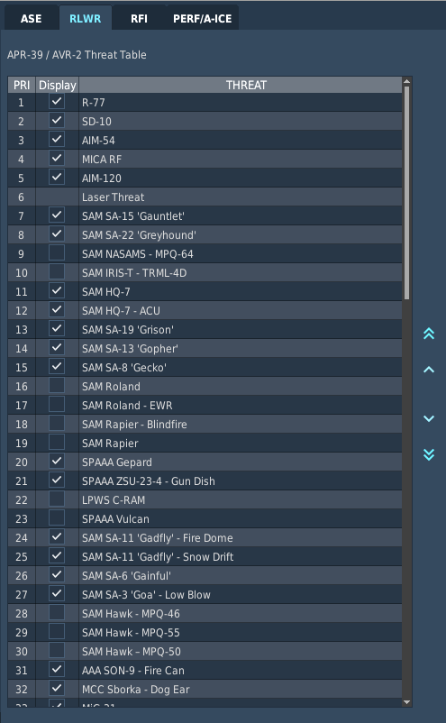
2. Index Arrows
1. Threat Table
- Threat Table. Displays the database of radar/laser threats and their priority.
  - PRI. Displays the priority index of the radar/laser threats. All radar/laser threats are prioritized by lethality over their position in the priority index or relative signal strength. Radar/laser threats detected in a missile guidance mode will out-prioritize radar threats detected in a target tracking or search mode and designating or ranging lasers, regardless of their positions in the priority index; and radar threats detected in a target tracking mode or designating lasers will out-prioritize radar threats detected in a search mode or ranging lasers, regardless of their positions in the priority index.
  - Display. When this option is checked, the signal characteristics of the radar threat will be included within the threat table. When this box is un-checked, the APR-39 will not process this type of signal and will not display this threat on the ASE or TSD pages nor provide audio warnings to the crew.
  - THREAT. Displays the type of radar/laser threat.
- Index Arrows. When the up or down arrows are pressed, the selected radar/laser threat is moved upward or downward, respectively, within the threat table, allowing threat priorities to be re-ordered if necessary.
When the double up or down arrows are pressed, the selected radar/laser threat is moved to the first or last priority position, respectively, of the threat table.

Performance/Anti-Ice Modes (PERF/A-ICE)
The PERF/A-ICE tab allows the user to edit the pressure altitude, air temperature, and gross weight values for the MAX and PLAN modes on the PERF page, or set the default operating mode of the anti-ice system.

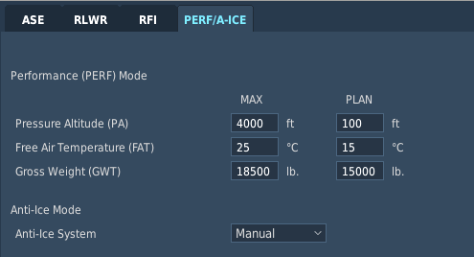
1. Performance Parameters
2. Anti-Ice Mode
- Performance Parameters. Displays the maximum and planned environmental and gross weight conditions that are expected to be encountered during the mission.
  - Pressure Altitude (PA). Displays/edits the pressure altitude, between -2,300 and 20,000 feet in 1-foot increments.
  - Free Air Temperature (FAT). Displays/edits the air temperature, between -60° and 60° Celsius in 1-degree increments.
  - Gross Weight (GWT). Displays/edits the aircraft gross weight, between 10,000 and 25,000 pounds in 1-pound increments.
- Anti-Ice Mode. Selects the anti-ice mode of operation between Automatic and Manual.

